




Datasheet 12.8V 105Ah LiFePO4

Optimal replacement for lead-acid batteries with up to 10 times longer life
BullTron LifePO4 batteries are an optimal replacement for lead-acid batteries with all the benefits of Lithium Iron Phosphate batteries.
They offer up to 80% weight reduction, high energy reserves and stable tension even under extreme loads.
The batteries have been specially designed to provide the optimum balance of size, weight, power and life.

Extremely long life is guaranteed even with regular deep discharge (3500 cycles at 100% DOD or 6000 cycles at 80% DOD/depth of discharge) thanks to the latest Lithium technology, making BullTron® batteries the ideal backup battery.

The battery is suitable for 12V-48V systems
- Parallel connection 12V is possible (capacity increase)
- Series connection 24V, 36V, 48V also possible

Advantages of BullTron Batteries
- Packaging & assembly in Germany
- 5 Jahre deutsche Herstellergarantie
- 5 year German manufacturer warranty
- Service, maintenance and repair in Germany (within 1 day)
- Bolted case (can be opened)
- No glued & welded components
- All components (cells & BMS) replaceable (screwed)
- Use of high quality & durable components
- Up to 75% longer cycle life than other LiFePO4 batteries
- Up to 45% smaller and 35% lighter than other LiFePO4 batteries
- Battery sizes up to 540Ah suitable for under-seat mounting
- Automatic battery cut-off in the event of a short circuit

Safest Lithium Technology (LiFePO4)

BullTron batteries use Lithium Iron Phosphate (LiFePO4) technology, the safest lithium technology on the market today. All batteries consist of powerful and very durable (LiFePo4) cells and an integrated Battery Management System (BMS). The BMS permanently protects individual cells and the entire battery against over/under voltage, over/under temperature, overload and short circuit (automatic shutdown without damage).
The BMS effectively prevents premature battery failure due to external factors or misuse.

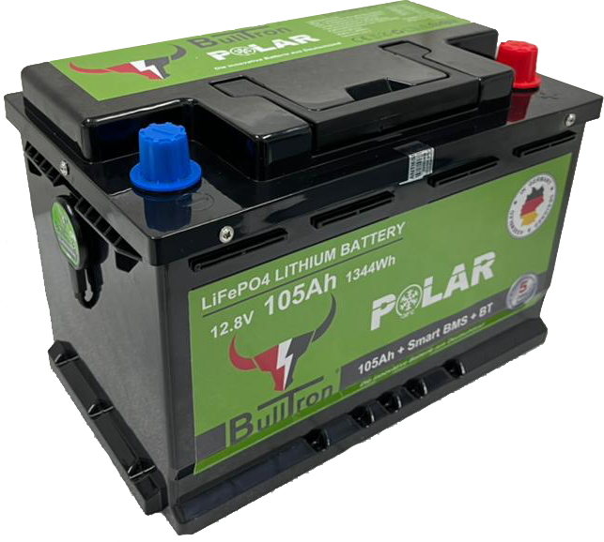

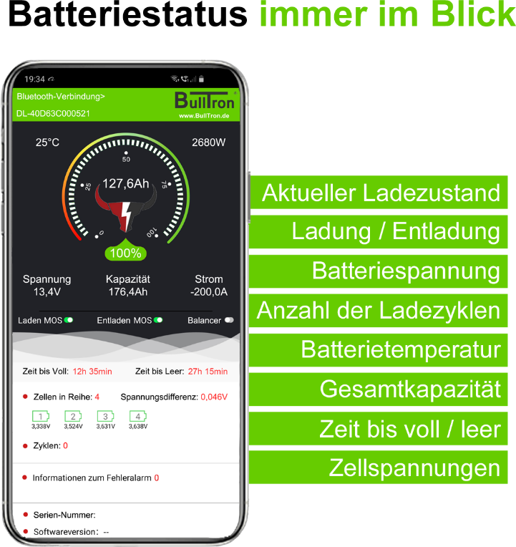



Bulltron GmbH - Auf der Hude 88, D-21339 Lüneburg - www.bulltron.de - info@bulltron.de - Tel.: +49 (0) 41 31 - 2 19 12 89

Technical specifications 12.8V 105Ah

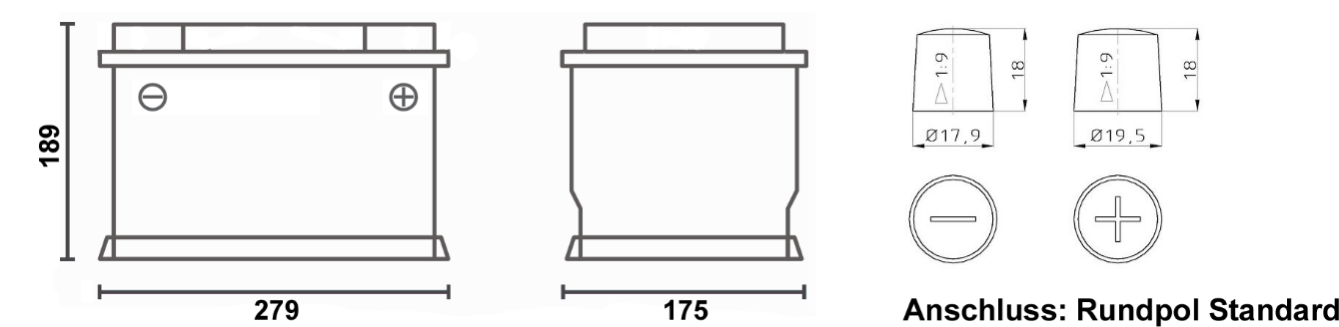

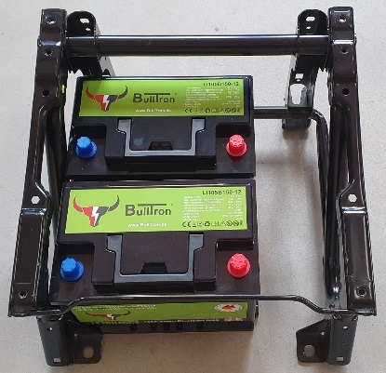
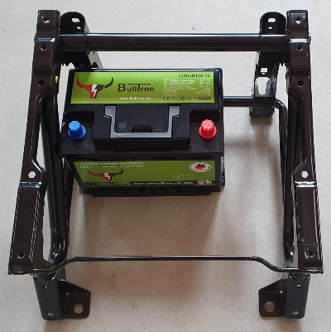
Even when installing 2x 105Ah Bulltron batteries, there is still enough space under the seat to install a solar charge controller, charge booster or inverter, for example, as these batteries are approx. 7.5 cm shorter than the original 95Ah lead/AGM/GEL batteries. The height, depth, connectors and mounting points are identical.
So you can easily double the capacity, gain space & save 34kg of weight at the same time.

Modell | LI105B150-12-P
EAN / GTIN | 4262358250094
Rated Capacity | 105Ah / 1344Wh
Rated voltage | 12.8 V
Cycle life (with 80% capacity remaining) | ≥3500 bei 100% DOD
Cycle life (with 80% capacity remaining) | ≥6000 bei 80% DOD
End of charge/absorption voltage | 14.2 - 14.6V
Float Voltage | 13.5 - 13.8V
Max. recommended charge current | 50A
Max. Charge Current | 100A
Discharge Current Duration | 150A
Max. Discharge Current | 300A
Battery Management System (BMS) | Integrated Smart BMS with 5A active balancer
Monitoring | Bluetooth 4.0 with Smartphone App
Application / Wiring | 12V installation also possible in parallel
Application / Wiring | Series connection to 24V, 36V, 48V also possible
Protection Class | IP65
Temperature Range (Discharge) | -20°C ~ +60°C
Temperature Range (Charge)* | -30°C ~ +55°C
Temperature Range (Storage) | -20°C ~ +60°C
Connection | Round Pole Standard
Warranty | 5-year manufacturer's warranty
Weight | 10.5 kg
Dimensions (L x W x H) in mm | 279 x 175 x 189
Installation Options | Vertical and Horizontal Positions

* The built-in heater starts at temperatures below 0°C when a charge current is applied. The built-in heater does not discharge the battery.

Bulltron GmbH - Auf der Hude 88, D-21339 Lüneburg - www.bulltron.de - info@bulltron.de - Tel.: +49 (0) 41 31 - 2 19 12 89

